Tittle : Public Health Awareness Campaign Analysis

# Introduction:

* Transportation efficiency is a critical factor in urban planning and sustainability. This document initiates the process of analyzing public transportation efficiency using IBM Cognos for visualization. Beginning with an exploration of the concept of transportation efficiency, we aim to collect, process, and clean relevant data to facilitate in-depth analysis. This analysis will provide valuable insights for improving public transportation system.

# *Analysis Objectives:*

* The primary objectives of this project are to assess and improve public transportation efficiency. This involves evaluating factors such as ridership trends, route optimization, on-time performance, and environmental impact. We seek to leverage IBM Cognos for data visualization to gain actionable insights, enhance decision-making for transportation authorities, and contribute to more sustainable and effective urban mobility systems.
* At present we tried visualisations that show how NumberOfBoardings is distributed across routes, stops and a week.

# *Data Cleaning and Preprocessing:*

In [1]:

import numpy as np import pandas as pd

import osfor dirname, _, filenames **in** os.walk('/kaggle/input'):

for filename **in** filenames:

print(os.path.join(dirname, filename))

/kaggle/input/unisys/Public Health Awareness Campaign Analysis.doc

* **Age** is the general age of the Person
* **Gender** is the general character of the person
* **Mental Heath** is the based on the Human Mental Power
* **Physical Health** is the based on Human Physical Strength
* **Benefits** is the how the people get useful from the Campaign

# **Step-1:** Load the data set from the above link

<https://www.kaggle.com/datasets/osmi/mental-health-in-tech-survey>

# import pandas as pd = pd.read_csv('/kaggle/input/unisys/survey.CSV', low_memory=False)data.shapedata.head(10)

Load the Dataset



*# Step 2: Drop duplicates and Check data types of columns*data = data.drop_duplicates()import seaborn as snsprint(data.dtypes)

Age int

Gender String

Country String

Physical String

Health

Mental String

Health

Benefits String

*# Step 3: Check data types of columns*print("**\n**Check data types of columns")print(data.dtypes)

Age int

Gender String

Country String

Physical String

Health

Mental String

Health

Benefits String

*# Step 4: Handle mixed data types#’Timestamp' column has mixed types, convert it to numeric*data['Timestamp'] = pd.to_numeric(data[Timestamp], errors='coerce')print("Handle mixed data types")print(data.shape)

Handle mixed data types

(10857234, 6)

*# Step 5: Handle missing values# Drop rows with missing values or fill them based on your project required data*= data.dropna()print("**\n**Handle missing values")print(data.shape)

Handle missing values

(6414906, 6)

*#Step 6 : Unique values for each column in the DataFrame*print(data.nunique())

Age 1646

Gender 49

Country 49

Physical 49

Health

Mental 49

Health

Benefits 49

***Visualization on IBM Cognos:***

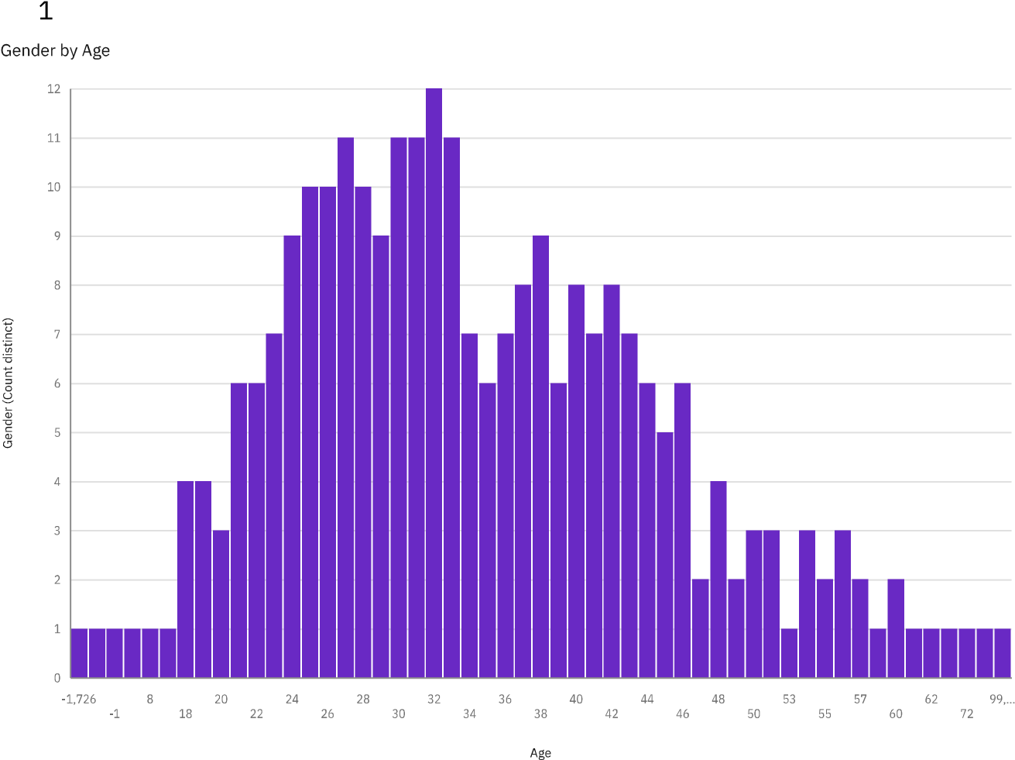

**Gender**  by **Age** is the bar chart which to take the people to survey in certain age to find male or female

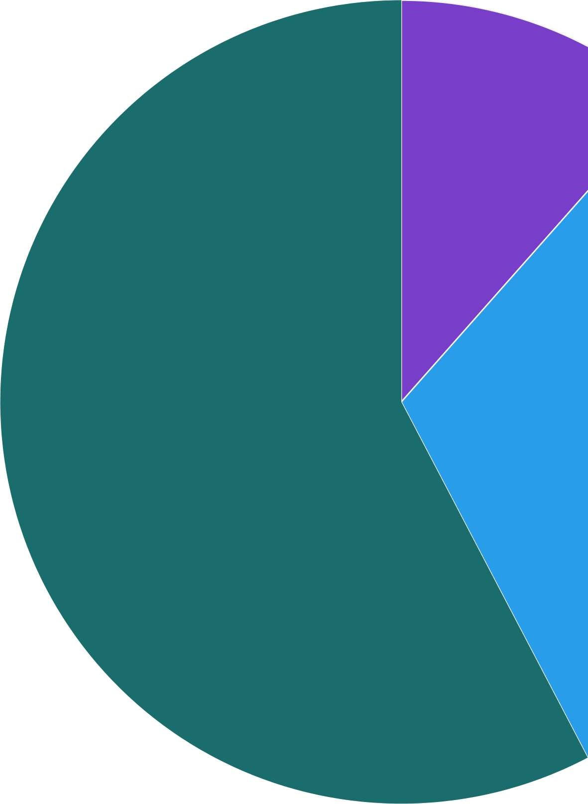

**State** by **self_employed** which means how the people are self employed by statewise

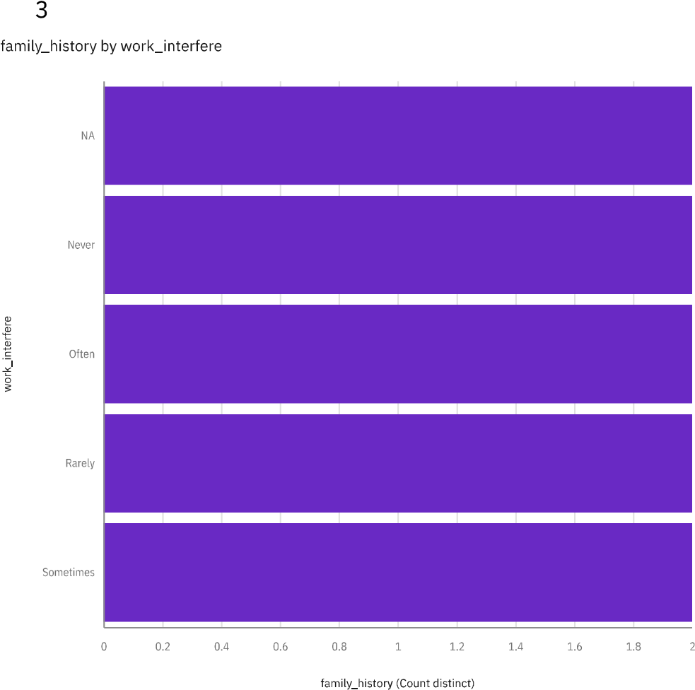 **Family history** by **work interfere** which people to make there doing the job

The person who benefit who by tech companys

**Leave** by **anonymly** who can take leave on sick or illnes

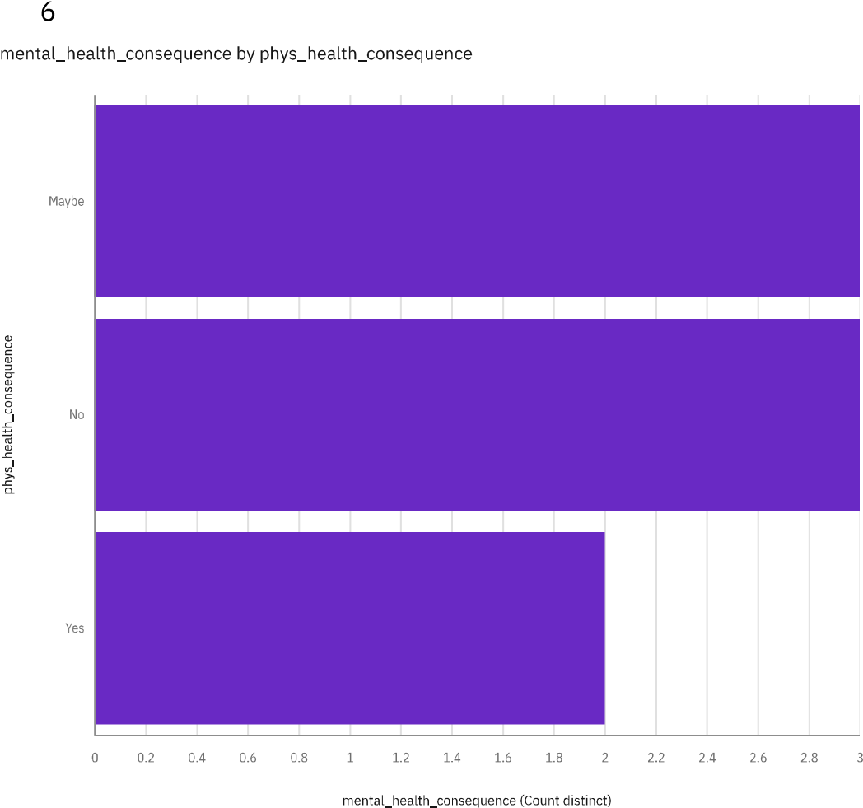

Person who can by **Mental_health** and **Physical_health**

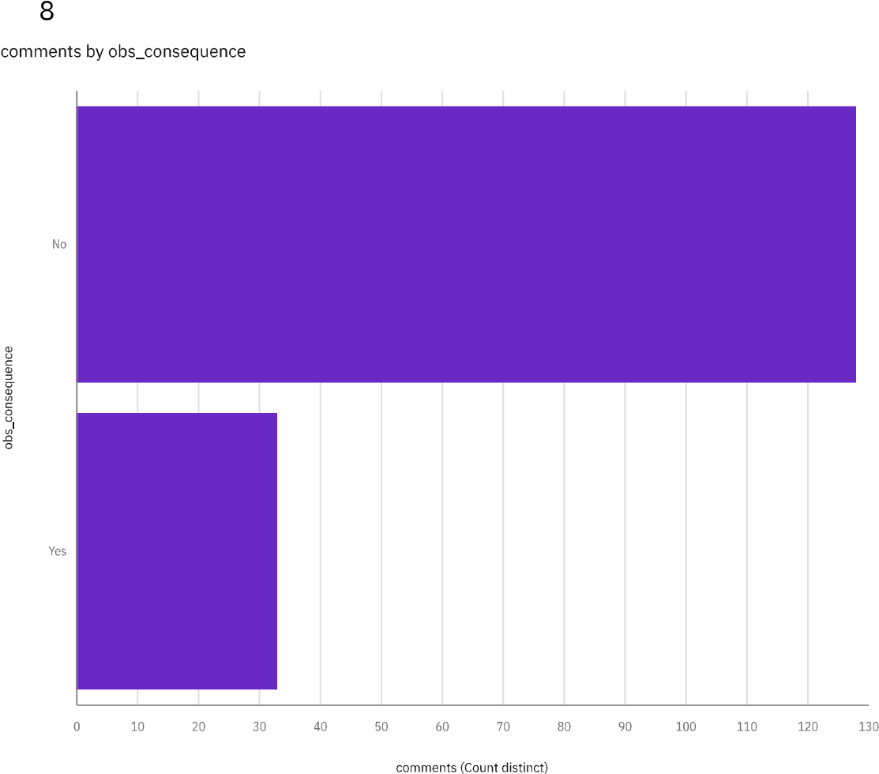 **Comments** by **obs_consequence** which the who see some consequences on the commented on that

# *Conclusion:*

In this initial phase of the project, the dataset was effectively processed and cleaned to ensure its accuracy and reliability. Subsequently, compelling visualizations were generated using IBM Cognos, setting the stage for a comprehensive analysis of public transportation efficiency. These preparatory steps are essential for facilitating informed decision-making and shaping the future of urban transportation systems.